COMPUTER FUNDAMENTAL LAB REPORT # 5

NAME | Haseeb Ahmad
REGISTRATION  NUMBER | BF25NWELE0678
DEPARTMENT | ELECTRICAL ENG  (comm.)
SECTION | “B”
SEMISTER | 2nd
SUBJECT | COMPUTER  PROGRAMING

- Objective:
The purpose of this lab is to learn and apply three types of loops in C++:
- The while loop:
Executing code based on a pre-checked condition.
- The nested while loop:
Running a loop inside another loop for complex iterations.
- The do...while loop:
Ensuring a block of code runs at least once before checking the condition.
2. Methodology & Examples
The while Loop
A "pre-test" loop. If the condition is false at the start, the code block is never executed.
- Example:
Printing "Hello" 3 times.
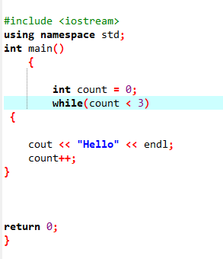

The do...while Loop
A "post-test" loop. This is useful for user menus where you want the prompt to show up at least once regardless of the condition.
- Example:
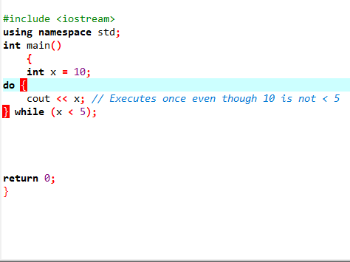
nested while loop :
A nested while loop is a programming structure where one while loop is placed inside the body of another while loop.
EXAMPLE:
